**ASP.Net MVC Viewer Sample**

* Download the sample project from Github
* Open the sample project in Visual Studio 2012.

You will find the code to do the authentication, uploading the chosen file to OSS and bubble creation under Controllers\HomeController.cs

You will find the Javascript code for the viewer related stuff under Scripts\MyScript.js

* Open HomeController.cs and provide the OSS Bucket name of your choice, the client key and client secret as obtained from <https://developer.api.autodesk.com>

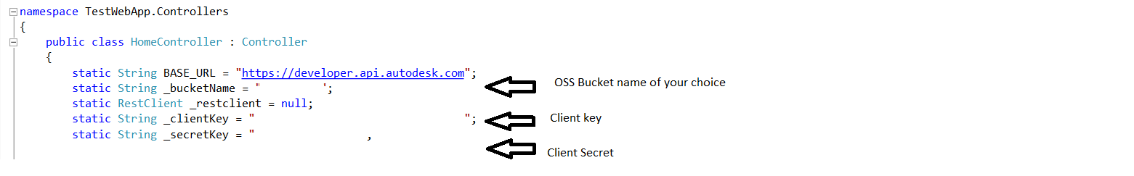

* Build the sample project and start debugging. You will see a screen as shown below.

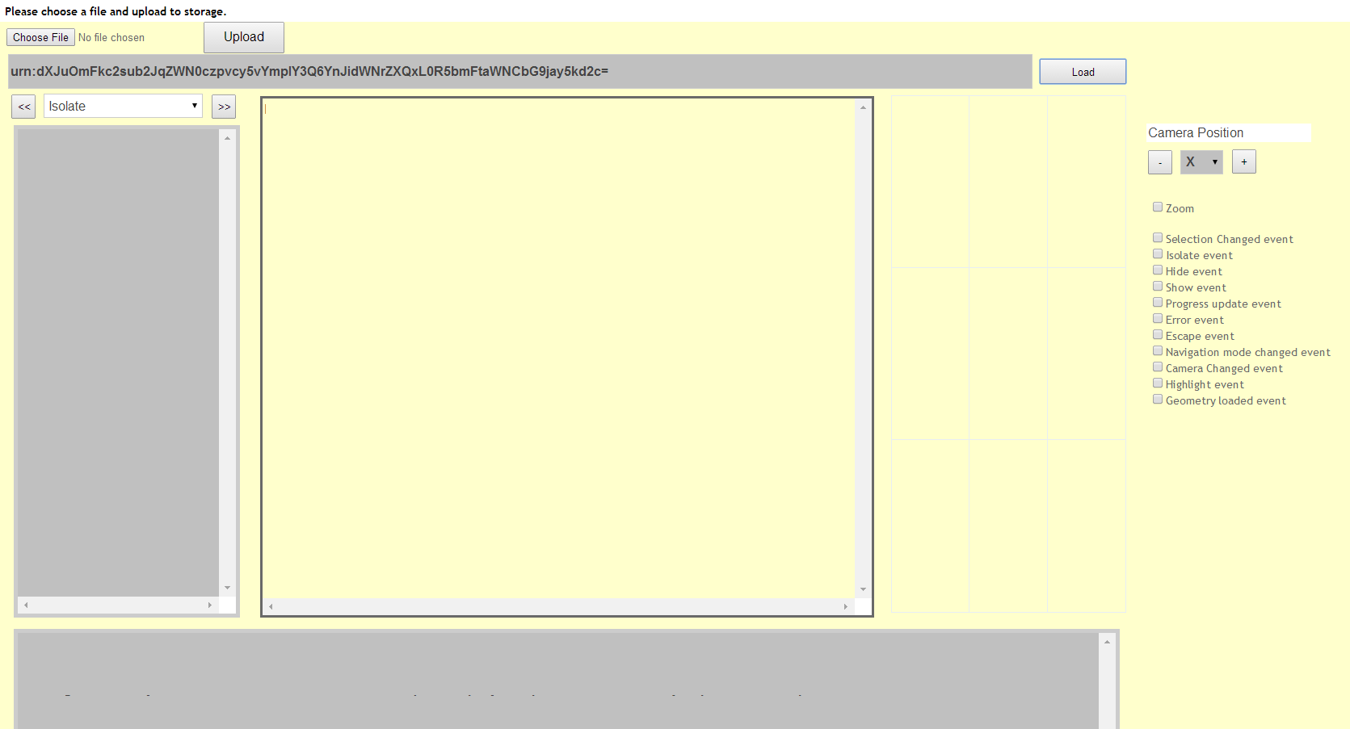

* Click on the “Choose File” button to select a file to upload .

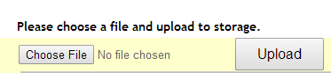

* Click on the “Upload” button to upload the chosen file to bucket and start bubble creation.

You will then see a message indicating the start of translation. Please wait until the translation of the uploaded file has completed. The message will change to the following after the translation is done.

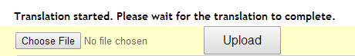

* After the bubble creation is completed, the Model URN is updated in the input box. For the viewer to load the new model, click on the “Load” button.



* After the model is reloaded, the viewer displays the model. Please note, at present there is a known issue with this sample regarding a delay in the viewer updating the model even after the document URN has been generated. Please try reloading the model after a few minutes if that happens.

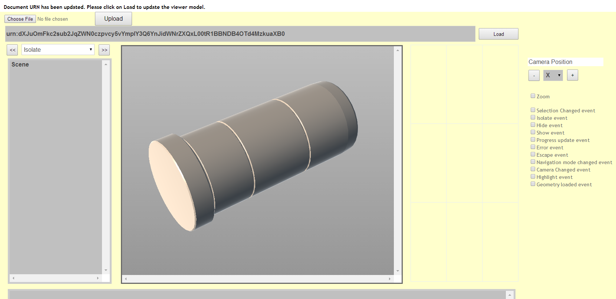

The model can be explored further using >> and << buttons. Some of the other features of the sample is as shown in the screenshot below :

